**IEEE I06 ASSIGNMENT 02 -DQN**

**Deep Q-Networks: A Practical Assignment**

**Assignment Tasks**

**Task 1: Environment Setup**

**Python Code:**

class Environment():

    #initalizing class with inital position and making grid

    def __init__(self):

        self.pos = (0, 0)

        self.grid = np.zeros((5, 5), dtype=int)

        self.obs = set()

    #function to reset grid and add obstacles

    def reset(self):

        self.grid = np.zeros((5, 5), dtype=int)

        self.pos = (0, 0)

        self.obs = set()

        self.obs.add((1,2))

        self.obs.add((2,2))

        self.obs.add((3,4))

        self.obs.add((1,0))

        self.obs.add((1,3))

        for obs in self.obs:

            self.grid[obs] = -1

        self.grid[0, 0] = 1

        self.grid[4, 4] = 2

    #function to move agent given an input action

    def step(self, action):

        y, x = self.pos

        if action == 0 and y > 0:

            newpos = (y - 1, x)

        elif action == 1 and y < 4:

            newpos = (y + 1, x)

        elif action == 2 and x > 0:

            newpos = (y, x - 1)

        elif action == 3 and x < 4:

            newpos = (y, x + 1)

        else:

            newpos = (y, x)

        if self.grid[newpos] == -1:

            return self.pos, -10, False

        self.pos = newpos

        reward = -1

        terminated = False

        if self.pos == (4,4):

            reward = 10

            terminated = True

        return self.pos, reward, terminated

    #function to render the grid

    def render(self):

        grid = self.grid.copy()

        grid[self.pos] = 3

        print(grid)

**Task 2: Implement DQN**

**Python code:**

class ReplayMem():

    #initializing class

    def __init__(self, maxlen):

        self.memory = deque([], maxlen=maxlen)

    #function to append data to buffer

    def append(self, transition):

        self.memory.append(transition)

    #function for sampling minibatches from buffer

    def sample(self, sample_size):

        return random.sample(self.memory, sample_size)

    def __len__(self):

        return len(self.memory)

class Agent():

    #initializing class

    def __init__(self, alpha, gamma):

        self.alpha = alpha

        self.gamma = gamma

        self.epsilon = 1.0

        self.loss_fn = nn.MSELoss()

        self.optimizer = None

        self.actions = ['U', 'D', 'L', 'R']

    #function that returns one out of 4 possible actions

    def sample(self):

        return random.randint(0, 3)

    #function to convert int input to tensor

    def convert(self, posi):

        inp = torch.zeros(25)  # 5x5 grid = 25 states

        inp[posi] = 1

        return inp

    #function to convert index input to tensor

    def converter(self, posi):

        x, y = posi

        inp = torch.zeros(25)  # 5x5 grid = 25 states

        inp[5 * x + y] = 1

        return inp

    #function to train agent

    def train(self, episodes):

        #set epsilon to 1 and declare memory buffer

        self.epsilon = 1

        memory = ReplayMem(maxlen=4000)

        # Define policy and target networks

        policy_DQN = nn.Sequential(

            nn.Linear(25, 32),

            nn.ReLU(),

            nn.Linear(32, 32),

            nn.ReLU(),

            nn.Linear(32,10),

            nn.ReLU(),

            nn.Linear(10 , 4)

        )

        target_DQN = nn.Sequential(

            nn.Linear(25, 32),

            nn.ReLU(),

            nn.Linear(32, 32),

            nn.ReLU(),

            nn.Linear(32,10),

            nn.ReLU(),

            nn.Linear(10 , 4)

        )

        #copy policy network onto target network

        target_DQN.load_state_dict(policy_DQN.state_dict())

        #declare optimizer and print policy

        self.optimizer = torch.optim.Adam(policy_DQN.parameters(), lr=self.alpha)

        self.print_dqn(policy_DQN)

        #declaring arrays for rewards and epsilon history

        rewards_per_episode = np.zeros(episodes)

        epsilon_hist = []

        #episode loop

        for i in range(episodes):

            #reset variables

            env.reset()

            terminated = False

            total_reward = 0

            step_count = 0

            #while loop to navigate through grid

            while not terminated and step_count<1000:

                step_count+=1

                #taking actions according to epsilon greedy policy

                if random.random() < self.epsilon:

                    action = self.sample()

                else:

                    with torch.no_grad():

                        action = policy_DQN(self.converter(env.pos)).argmax().item()

                #taking step and storing data in memory buffer

                init_state = env.pos

                new_state, reward, terminated = env.step(action)

                total_reward += reward

                memory.append((init_state, action, new_state, reward, terminated))

            rewards_per_episode[i] = (total_reward)

            #optimizing neural network in minibatches of size 64

            if len(memory) > 64:

                mini_batch = memory.sample(64)

                self.optimize(mini_batch, policy_DQN, target_DQN,i)

                if  i%100==0:

                    self.print_dqn(policy_DQN)

            # Decay epsilon

                self.epsilon = max(self.epsilon *0.9975, 0.1)

                epsilon_hist.append(self.epsilon)

            # Update target network

                target_DQN.load_state_dict(policy_DQN.state_dict())

        # Save the trained model

        torch.save(policy_DQN.state_dict(), "grid.pt")

        # Plot results

        plt.figure(figsize=(12, 6))

        plt.subplot(121)

        plt.plot(rewards_per_episode)

        plt.title("Rewards Per Episode")

        plt.xlabel("Episodes")

        plt.ylabel("Total Reward")

        plt.subplot(122)

        plt.plot(epsilon_hist)

        plt.title("Epsilon Decay")

        plt.xlabel("Episodes")

        plt.ylabel("Epsilon")

        plt.show()

    def test(self, episodes):

        env.reset()

        policy_DQN = nn.Sequential(

            nn.Linear(25, 32),

            nn.ReLU(),

            nn.Linear(32, 32),

            nn.ReLU(),

            nn.Linear(32, 10),

            nn.ReLU(),

            nn.Linear(10 , 4)

        )

        #loading trained model

        policy_DQN.load_state_dict(torch.load("grid.pt"))

        policy_DQN.eval()

        print('Policy (trained):')

        self.print_dqn(policy_DQN)

        #simulate episodes

        for i in range(episodes):

            env.reset()

            terminated = False

            step = 0

            #taking actions according to trained policy

            while not terminated and step<200:

                step +=1

                init_state = env.pos

                with torch.no_grad():

                    action = policy_DQN(self.converter(env.pos)).argmax().item()

                new_state , reward, terminated = env.step(action=action)

                env.render()

    #function to optimize neural net

    def optimize(self, mini_batch, policy_DQN, target_DQN, i):

        current_q_list = []

        target_q_list = []

        #loops through minibatch

        for init_state, action, pos, reward, terminated in mini_batch:

            #updates target according to bellman equation with alpha set to 1

            if terminated:

                target = torch.FloatTensor([reward])

            else:

                with torch.no_grad():

                    target = torch.FloatTensor((reward + self.gamma * target_DQN(self.converter(pos)).max()))

            #storing q values of policy and target network

            current_q = policy_DQN(self.converter(init_state))

            current_q_list.append(current_q)

            target_q = target_DQN(self.converter(init_state))

            target_q[action] = target

            target_q_list.append(target_q)

        #calculating loss

        loss = self.loss_fn(torch.stack(current_q_list), torch.stack(target_q_list))

        #optimizing the network

        self.optimizer.zero_grad()

        loss.backward()

        self.optimizer.step()

    #function to print policy

    def print_dqn(self, dqn):

        # Get number of input nodes

        num_states = 25

        # Loop each state and print policy to console

        for s in range(num_states):

            #  Format q values for printing

            q_values = ''

            for q in dqn(self.convert(s)).tolist():

                q_values += "{:+.2f}".format(q)+' '  # Concatenate q values, format to 2 decimals

            q_values=q_values.rstrip()              # Remove space at the end

            # Map the best action to L D R U

            best_action = self.actions[dqn(self.convert(s)).argmax()]

            # Print policy in the format of: state, action, q values

            # The printed layout matches the FrozenLake map.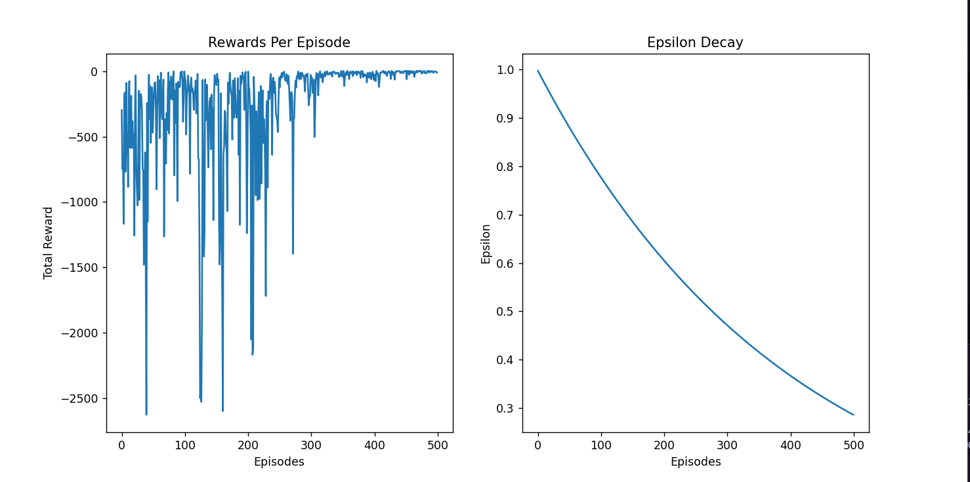

            print(f'{s:02},{best_action},[{q_values}]', end=' ')

            if (s+1)%5==0:

                print() # Print a newline every 4 states

**The above plots show the total rewards in each episode as well as the epsilon decay during training**

**Task 3: Analyze Performance**

After training the model for a few different obstacle placements(10) we can see that the model generally is successful in learning the optimal policy

Ex:

For the given grid, the rewards per episode vs episode graph is shown.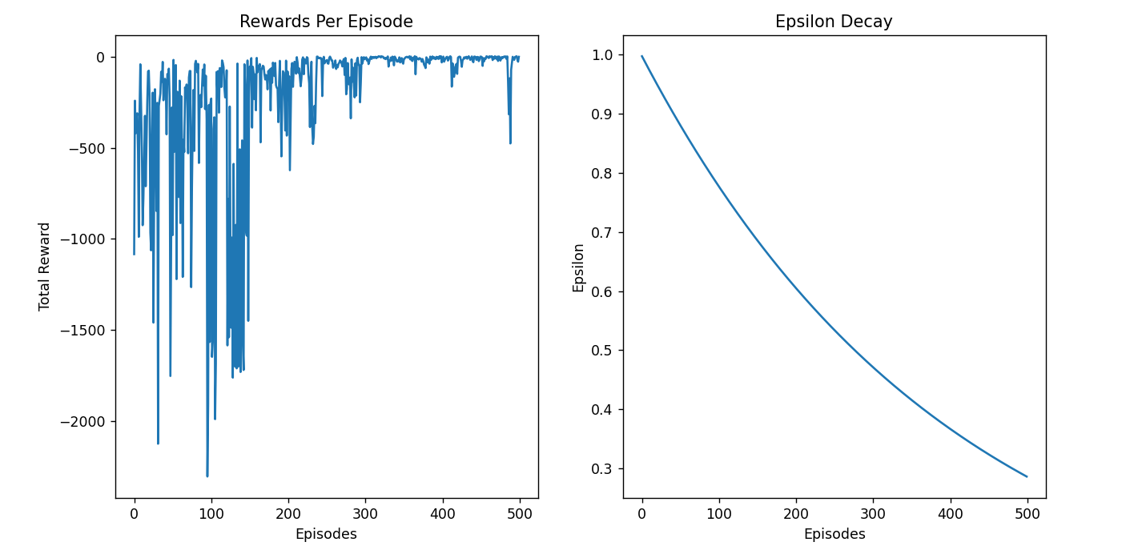

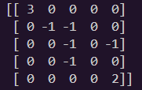



**The policy learned by the agent. The letters symbolize the optimal step that can be taken in each state**

If we use the policy to traverse the grid we see that the agent always reaches in the end in minimum number of steps ensuring 100% success rate. But the caveat is that the agent fails to learn to optimal policy in some cases(some initial states of the network cause the agent to be unable to find the optimal policy)

**Visualization:**

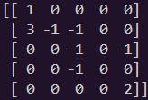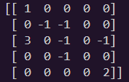

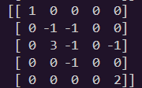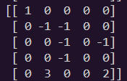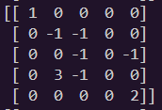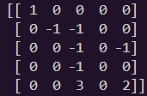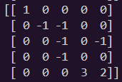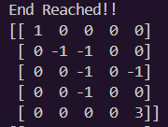

**0s represent free space, 1 is the start, 2 is the end and 3 represents the current position of the agent.**

**Out of 10 different obstacle placements, the agent was able to learn the optimal policy 5 times on the first training session. Which gives us a 50% success rate. (Although this is not accurate as the sample space is too small)**

**Some Important Observations:**

* The agent showed greatly increased efficiency when the learning rate of the optimizer was changed from 0.001 to 0.01.
* The agent needed more steps before termination as it couldn’t find the goal in most cases and just settled for not colliding with obstacles.
* The size of the replay memory buffer needs to be sufficiently large.
* Using a learning rate scheduler might be necessary as the model needs high learning rate at the start to learn the policy but might need to fine tune it later
* Using a specialized initializer might help with the cases where the agent isn’t able to find the optimal policy.
* Using exponential decay instead of linear decay of epsilon helped to improve the model.